# Using delimited prompts with f-strings

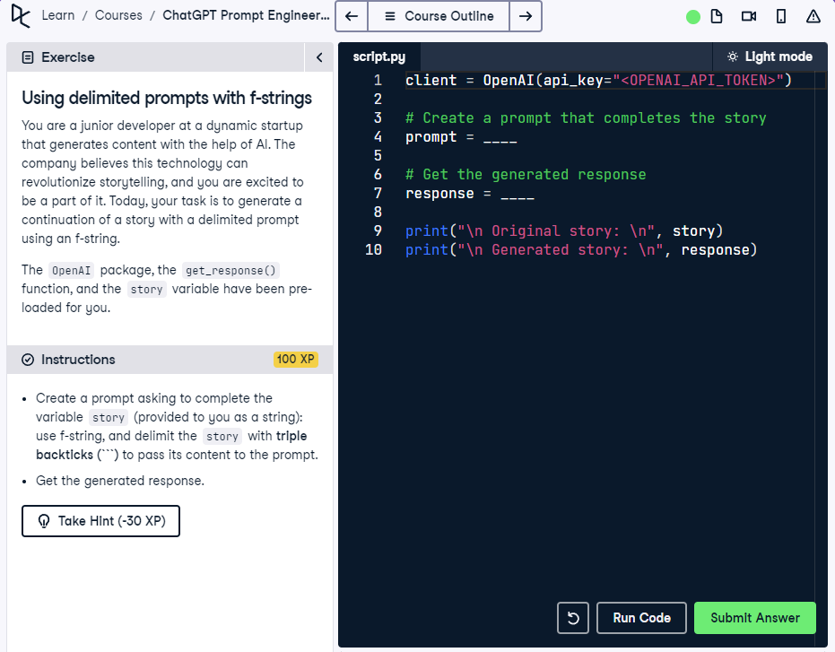

## Question

Create a prompt using an f-string that clearly asks to complete the `story`, and delimit it using triple backticks (```).

## Question Explanation

This exercise focuses on correct prompt formulation using f-strings and triple backticks. The prompt must clearly ask the model to complete the `story`, with the story content wrapped inside triple backticks to maintain clarity and formatting for better model interpretation.

## Answer

client = OpenAI(api_key="<OPENAI_API_TOKEN>")  
  
# Create a prompt that completes the story using triple backticks  
prompt = f"Please complete the following story delimited by triple backticks: ```{story}```"  
  
# Get the generated response  
response = get_response(prompt)  
  
print("\n Original story: \n", story)  
print("\n Generated story: \n", response)

## Answer Explanation

The prompt now explicitly tells the model to 'complete the following story' and identifies the use of triple backticks for delimiting. This provides clarity and structure, guiding the model accurately. The prompt is formed using an f-string, and get_response fetches the continuation.